
Haul NRT Design Guide

Haul NRT Web Application Design Document
Document Reference

Release Date
Document Location :

- Documentation change log
Document signoffs should be included here as per document change control standards.
Disclaimer:
This document is protected by copyright, no part of this document may be reproduced or adapted without the consent of the originator/company owner, all rights are reserved. This document is “uncontrolled when printed”, refer to electronic copy for up to date version.
 | Product Handover : Fortescue Insights |  | Doc Ref
Revision Number | 1.1 |  | 2/06/2017
Status | DRAFT |  | 2/06/2017
Authors | Premkumar Shanmugam | Signature | Click here to enter a date.
Checked | PremKumar Shanmugam | Signature | Click here to enter a date.
Accepted  IT Applications Development | Simon Yeoman | Signature | Click here to enter a date.
Confidentiality | Fortescue Staff & Contractors | Publish on Extranet | ☐ Yes
Confidentiality | Fortescue Staff & Contractors | Publish on Extranet | ☐ No
Review Date | Click here to enter a date.

Revision History (to be completed for each version retained by Document Control)
Author | Checker | Approver | Rev No. | Status | Issued Date
Srilakshmi Srinivasan | PremKumar Shanmugam | Arunprasath | 1.0 | Choose an item. | Click here to enter a date.
Sourabh Tewari | PremKumar Shanmugam | Arunprasath | 1.1
Soruabh Tewari | Arunprasath | Simon Yeoman | 1.2

Handover Details
Attendee | Signature |  | Date

TABLE OF CONTENTS
1. Documentation change log 2
2. Document purpose 5
3. Current Infrastructure 6
3.1 Issues with the current infrastructure 6
4. Proposed Infrastructure 7
4.1 How proposed infrastructure helps 7
5. Current application architecture diagram 8
5.1 Issues with current architecture 8
6. Proposed application Architecture 9
6.1 How proposed architecture solves existing issues 9
7. Component architecture diagram (Current) 10
7.1 Issues with the current component architecture 10
8. Component architecture diagram (proposed) 11
8.1 How the current architecture solves the problem 11
8.2 Different Systems involved 11
8.3 Different components involved 12
8.4 JHM proxy client 13
8.4.1 Security 13
8.5 Current DB Diagram 14
8.6 Proposed DB diagram 15
9. Environmental Management 15
9.1 Production change decision tree 15
10. Change management process 16
10.1 Stakeholders 16
10.2 Change window 16
11. Release Process 17

- Document purpose
The document provides an architectural & technical overview of the Haul NRT web application.
This document is intended to capture and convey the significant architectural & technical decisions which have been made in designing and building the system. It is a way by which the systems’ architect and others involved in the project can better understand the problems to be solved and how it will be represented with this system.
The following diagram shows the different steps taken to set and get information from the data:

- Current Infrastructure

The current infrastructure is hosted inside the FMGOPS network. It consists primarily of the following components:
- The IIS server which hosts the web application.
- Database, which is hosted on a SQL Express edition server. The database is also hosted by SOLFMSIIS01.
- The end user operator.
  - Issues with the current infrastructure
- Database server and application server are hosted by the same piece of infrastructure.
- SQL Server edition used is an express edition which limits the storage space(10 GB per Database) for the database which can be stored at a time. More information SQL Server Editions - Comparison.

- Proposed Infrastructure

  - How proposed infrastructure helps
The proposed infrastructure addresses the issues and concerns which arose due to the current infrastructure. The pain points are addressed in the following ways:

- The database proposed is an industry standard for an enterprise grade application and this is hosted on a server optimized and meant for database operations.
- There is a clear separation of concern between the application and storage policies.

- Current application architecture diagram
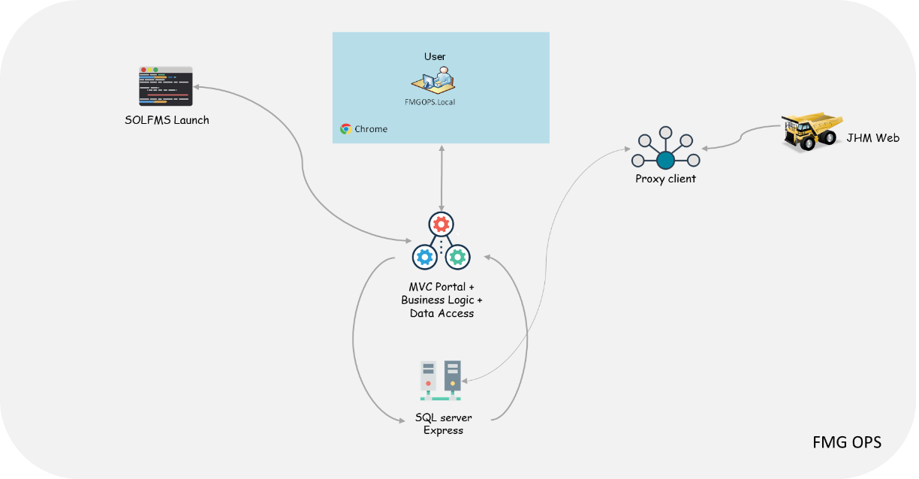

Haul NRT Application provides an interface to access different sets of information. It also has multiple components to support the application. The end user is provided with a means to access various information sets like Dash Board of the Device, JHM data and VNC to the device. It also provides an alert mechanism to the user to identify and access various states of the device.

The important supporting components for this application are
- JHM Proxy Service
- Haul NRT Application
- SolFmgLaunch Application

  - Issues with current architecture
- There is no polling mechanism. Its currently dependant on an executable running without any recovery and restart mechanism in place.
- There is no interface segregation between the components of the JHM Proxy.
- There is a dependency to access only via Chrome.
- The web portal consists of both the client as well as server components. It is tightly coupled. Best practice is to separate out the client and API components.
- There is no Scheduling component to enable interval-based event detection and module scraping.

- Proposed application Architecture
  - How proposed architecture solves existing issues
- Polling mechanism is passed down to the scheduler component.
- The proposed architecture consists of a clear separation of concerns across components for each of component activity, as part of the overall architecture.
- The portal can be accessed via any web browser.
- The server and client components have single responsibilities which helps in achieving stable performance and avoid unforeseen bottlenecks.
- Polling mechanism is passed down to the scheduler component. Scheduling processes for event detection and module scraping across components are handled by the scheduler.

- Component architecture diagram (Current)

  - Issues with the current component architecture
The current component doesn’t consider the polling and scheduling mechanism. This can affect the complexity and overall performance of the application.

- Component architecture diagram (proposed)
  - How the current architecture solves the problem
The scheduler component is added to take care of the performance and complexities which involves a job scheduling mechanism to take care of interval-based event detection and data scraping. The intervals are configurable across all events and data collections.
  - Different Systems involved
Current | Proposed
Jhm2cgiApp.cgi  This provides data to JHM service which contains the truck information. It provides truck information based on timestamp | VIMS (Vital Information management system)  Various VIMS modules present on a truck relay information about various sensors present. For example, type pressure, struts pressure, peak frame, payload.
Dash  This gives the dash board view of the device. It also provides a visual view of the dash board located on all devices. | TyreSense  TyreSense provides data related to the tyres present on the truck. It provides vital real time information for temperature and pressure.
JHMWeb  This give the jhm web view of the device which shows device information at real time. | Crusher feed rate  Provide crusher feed rate for the three crushers present.
TightVNCViewer
This is another tool used in the client component to view the VNC details.
FMGOps Systems
RD shadow session can be taken for all FMG Ops systems that can be accessed via a remote desktop viewer.

  - Different components involved
Current | Proposed
JHM Proxy  This is an important service in the application. It collects all the available truck information from DB then fetches the relevant JHM data and truck details from Jhm2CGIApp service and store it back in SQL DB. | Scheduler  The scheduler holds the pieces of trigger and job mechanism. All the services which need to be run in intervals are fired using the scheduling mechanism.
JHM proxy API
This service is continuously running every 2 seconds and polling the truck information and its status.
Solfmglaunch
This is an application created to verify the authentication and enable the users to view Dash board, VNC and RD sessions for all the devices

It uses the specific tools to launch each application. If user wants to open a dash board, then it opens the chrome browser and launches the view of the dash board by IP address.

  - JHM proxy client
The JHM proxy client uses a scheduling mechanism to capture, detect, historize and report sensor data.
    - Security
Since the application will reside in a “Controlled” space inside the Ops n/w, the internal security is taken care.

The portal will use the SSL (https) protocol to transmit data in a secured fashion.

Authorization to the application will be taken care by creating necessary user groups to provide information and data back to the end user.

An audit mechanism will be used to monitor the user interaction within the application which will involve making changes to various thresholds as this will affect the production environment.

A hard-limit will be set for minimum thresholds which can be set.

The client and API components will reside on separate boxes for which there will be API level security to check for any un-authorized usage.

There are pre-existing flaws related to remote desktop shadow for which there is no real-world solution other than to open the interface with restrictions (permissions to the feature) in place.

  - Current DB Diagram
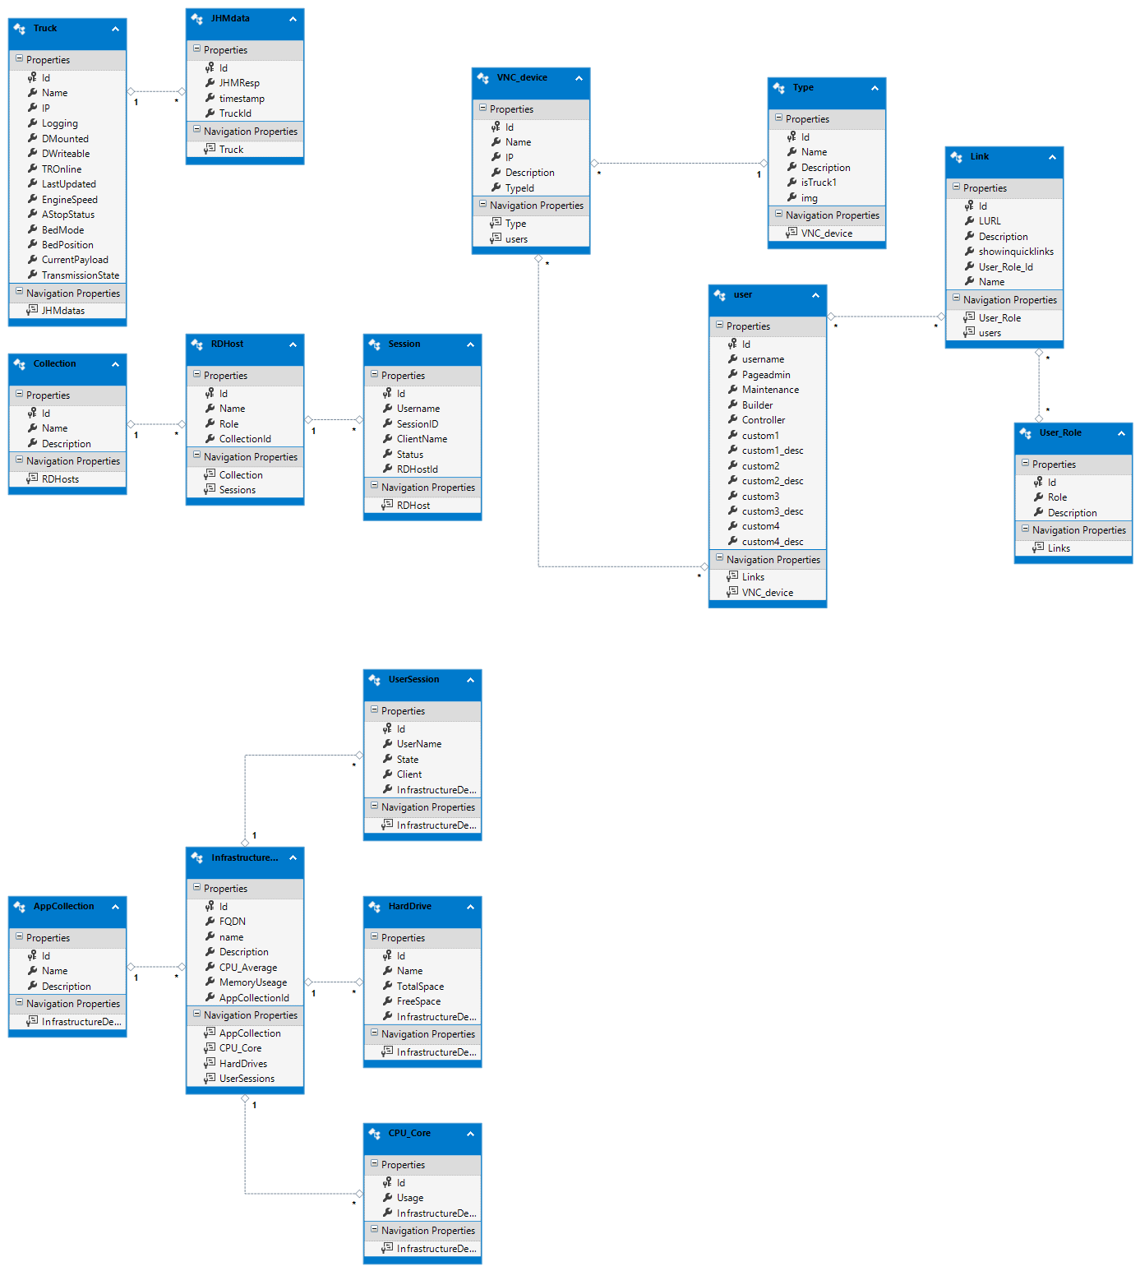

  - Proposed DB diagram
Currently the design modifications are underway.

- Environmental Management
An environmental management process will allow the team to develop new capabilities, fix production issues quickly without causing regression, and offer a system to train users on the new capabilities.

  - Production change decision tree

- Change management process

The change management process involves
  - Stakeholders
Solomon
Peer reviewer | Arunprasath Senthikumararaj
Business approver | April Scott and Kristen Campisi
Risk Approver from CAT | Shane Axman and Marcel Stoelman
Change Coordinator | Simon Yeoman

  - Change window
High Risk | Start of day shift (6am) on either Wednesday or Thursday) – these would include changes which involve communications with the trucks.
Low Risk | mid-morning after reporting and morning stats are completed (9am – 10am) – these would include changes to the portal/UI or database event capture.

- Release Process
A release process helps with a consistent planning of associated tasks:

- Communication
- End-user training
- Support team training
- Prevent changes made directly into production

To ensure sandbox architecture supports, we will use the following release plan:

- Break-fix
- Minor release
- Major release

Break fix: will consist of bug fixes and configuration fixes.

Minor releases: will have limited testing which does not impact day-to-day business or requires significant training.

Major Releases: Provides new features sets which will require significant testing and training.

